Developing New Technologies to Monitor Ecosystem Health – Indigo V Expeditions

Executive Summary

The marine microbiome underpins the very foundation of ocean health. Despite this critically important role, we know very little about the microbiome except that it is very sensitive to climate change, particularly ocean acidification and rising temperatures. Therefore, we can liken the microbiome to the proverbial canary in the coalmine because it is the first to show signs of stress on a changing planet.

Indigo V Expeditions is dedicated to developing novel tools and technologies to better understand the marine microbiome, a vast community of beneficial microbes, known collectively as plankton.

We developed tools that can identify precursor conditions that can lead to catastrophic downturns in ecosystem health. Just as we monitor out vitals to check our own health, so we can monitor the microbiome.

But the microbiome is vast in size. There are over one million beneficial microbes in one drop of seawater. We developed protocols to crowdsource ocean samples, tools, and proprietary equipment to scientifically analyze these samples. Much of our work was conducted in BIOT.

Over the course of five years, Indigo V Expeditions has completed three expeditions to Chagos Archipelago.

In 2013, our purpose was to establish a protocol for citizen scientists to help us gain more data points on the microbiome. We established citizen sailing oceanography as a way to crowdsource ocean data and get sailors invested in ocean health. We also established a health baseline in Chagos. We then photo-documented the condition of the reefs before the catastrophic bleaching event in 2015.

This expedition was a great success. We discovered that the composition of microbes inside the Salamon Atoll is totally different from just outside the atoll, despite regular and free exchange of water, and that the microbiome inside the atoll is more similar to the Bay of Bengal than to local waters. Therefore, we found that Chagos is home to a very unique and specific microbiome, which provides a compelling reason to preserve this marine area.

In 2016, we returned to further refine our technologies and conduct further studies of Chagos’ unique microbiome. We also partnered with Oxford Nanopore to sequence the microbiome in the field and develop real time ocean health monitoring. Additionally, we wanted to determine the reason why the microbiome composition is so unique. So we took water samples to compare against our ‘baseline’ samples collected in 2013. We ran viral productivity experiments, hypothesizing that they were predating on the microbiome. We also documented the decline of the reef, following the hottest El Nino on record. We estimate that 90% of the reef was affected by this event.

This expedition was also a great success. We discovered that viruses play a key role in determining the composition of the microbiome, and we were able to further development our ‘ocean health’ monitoring technology directly from the field.

In 2018, we returned to further track the recovery of the reef, to field trial the latest version of our auto-sampling equipment, and collect water samples to look for virus diversity. There were some signs of recovery of the reef itself, but the water column was still very murky, which blocks vital sunlight from the corals.

- Pics
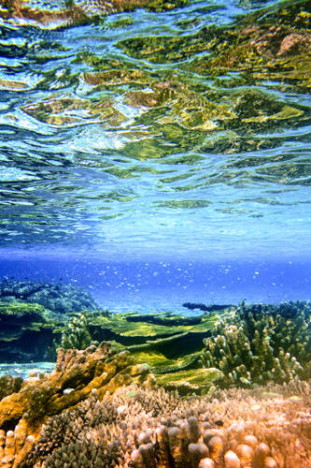

2016 Pics
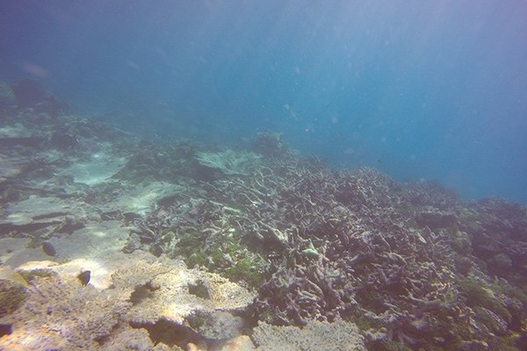

2018 Pics

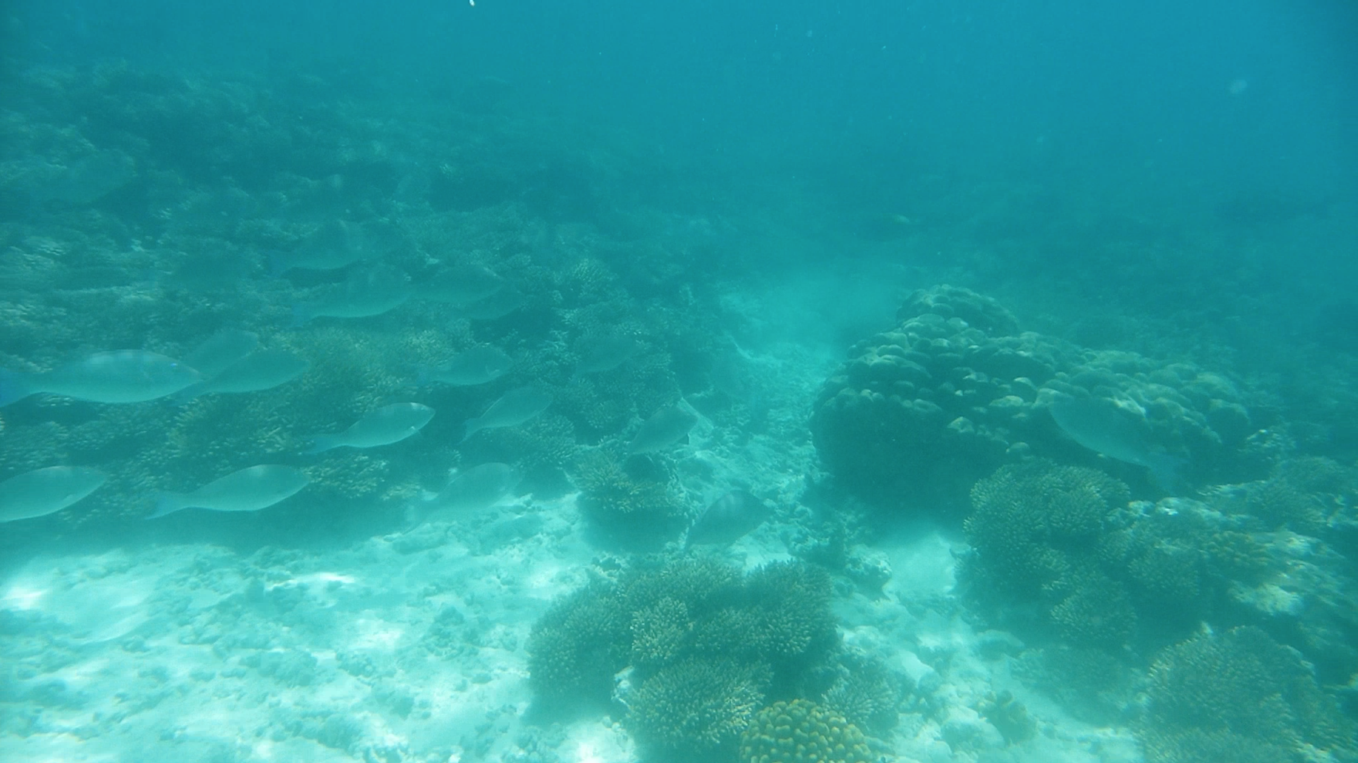

We deemed our expedition to be a success. We collected and stored collected water samples in Saloman and Perhos Banhos, both inside and outside the atoll. We also conducted photo and video surveys of the condition of the reef.

Setting up a transact for coral surveys.

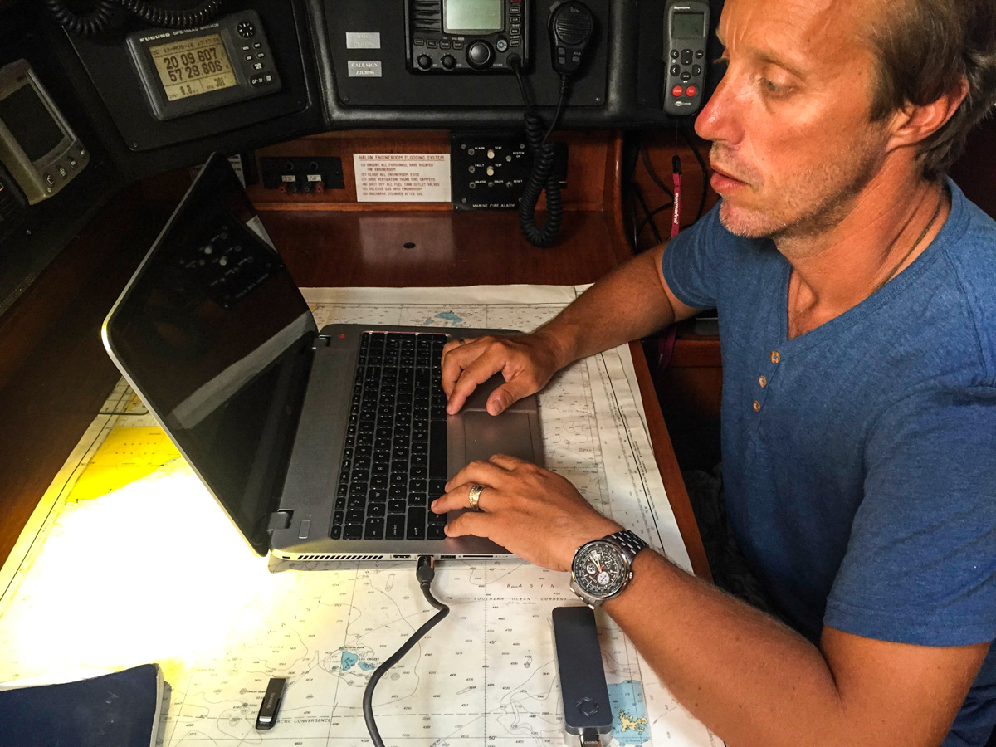
Running DNA sequencing on the Nanopore MinION.

We sampled water in both inside and outside Salamon Atoll and Perhos Banhos. The blue circle represents a marked reduction in the amount of chlorophyll found in the water column. We repeated these sampling stations in 2018.

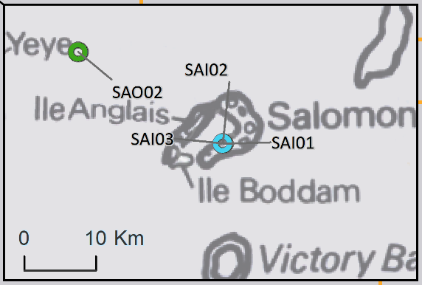

We have yet to sequence our water samples. Conclusions will follow after we complete a full analysis of the samples and compare them against our previous samples, which will occur towards the end of 2018.

We would like to thank BIOT for allowing us permission to conduct our studies in this beautiful pristine part of the world, and to our scientific collaborators and supporters along the way, especially The Explorers Club.

